

**S160X series induction switch specification**

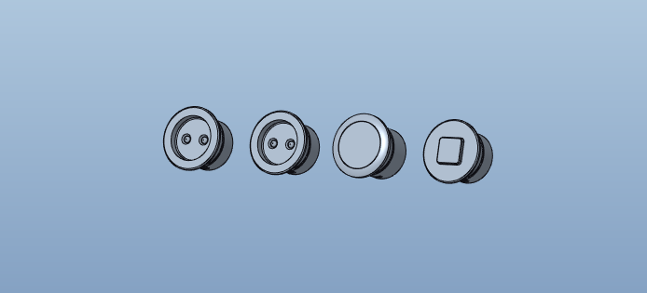

Product model: S1602/S1603/S1604/S1606

Version: V1.0

Date: October 19,2022

Business Telephone:(965)232-5320

Company:ARTCILUX LIGHTING INC

Address:1024 FAIRVIEW

**Product Parameter**

|  |  |  |  |  |  |
| --- | --- | --- | --- | --- | --- |
| model | type | size （MM） | sensing distance | working voltage | way to install |
| S1602 | Door touch | Φ16×10 | 3-5MM | DC12V/24V | Embedded / exposed |
| S1603 | A hand swipe | Φ16×10 | 3-5MM |
| S1604 | touch | Φ16×12.3 | 0MM |
| S1606 | human body induction | Φ16×10.7 | 1-3M |

**dimensional drawing**

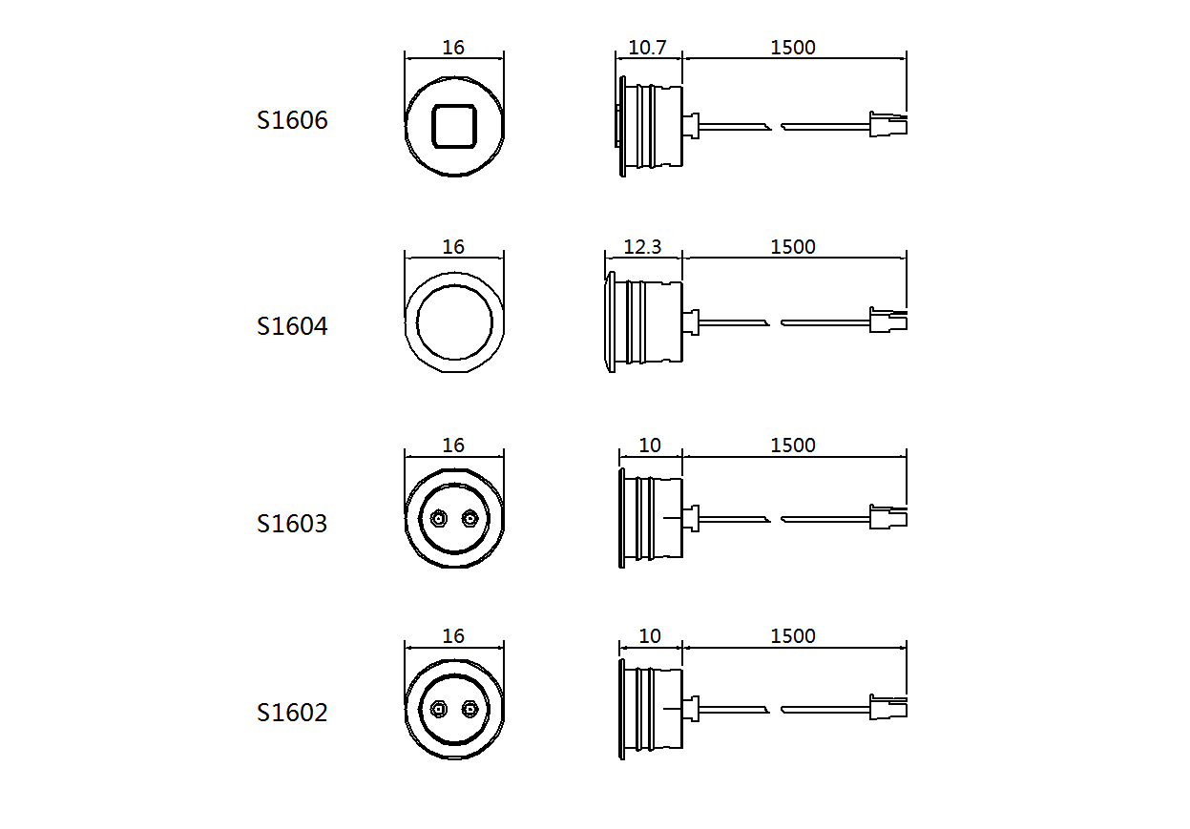

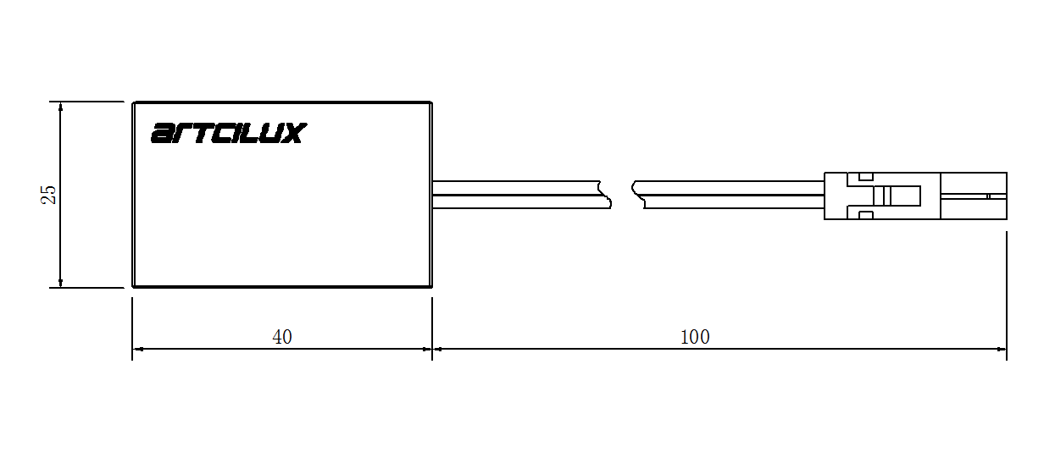

**application scenarios**

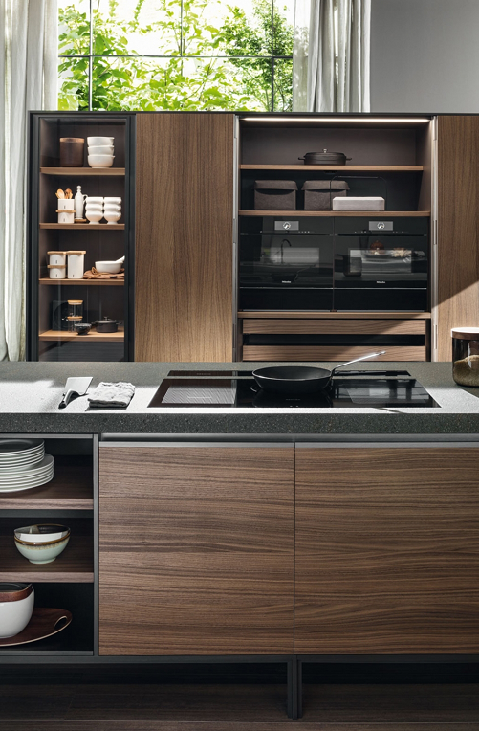 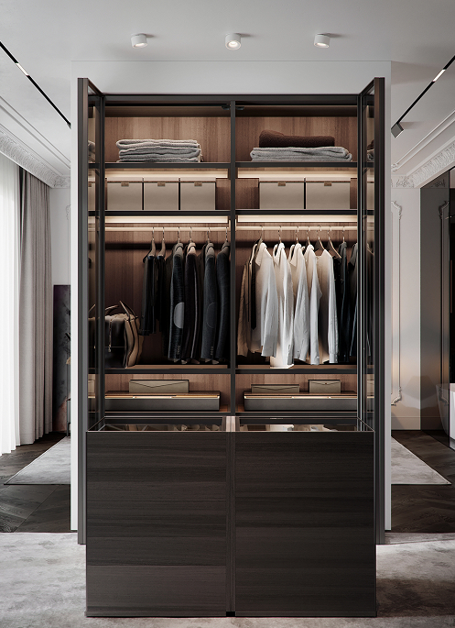

**Safety instructions**

For indoor use only.

Please regularly check for damage to the wires, transformers and all other parts. Do not use the product if any parts are damaged.

When installing and using the switch, please strictly follow the requirements of this manual.

Please do not install the switch where water droplets leak.

**maintenance**

If there is a quality or fault problem, please replace the whole set of switch devices.

**Please use a dry cloth to clean, do not use strong cleaning agent.**