

specification
S1314SE.DIM Wireless single key touch remote control switch
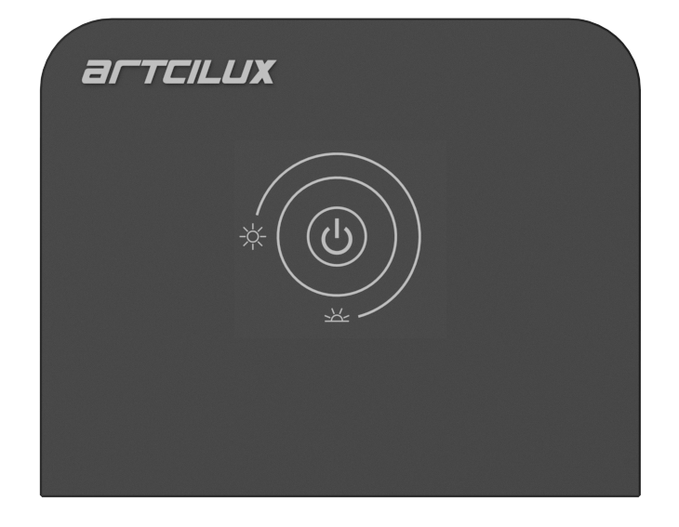
Product model: S1314SE.DIM
Version: V1.0
Date: December 27,2022
Business Telephone:(965)232-5320
Company:ARTCILUX LIGHTING INC
Address:1024 FAIRVIEW

I. Product overview
S1314SE.DIM The wireless single-key touch remote switch uses a 2.4GHz wireless RF control method, which can be paired with our company's control box to achieve wireless control of the lighting fixtures. It features replaceable CR2450 button batteries, allowing for a wireless control box that can operate over distances of up to 10M in open areas. The design is elegant and luxurious, with a clean and refined appearance; it uses advanced low-power chips, ensuring a long standby time. This product offers environmental protection, energy efficiency, ease of use, and no need for wiring, making it an excellent solution for controlling LED lighting in furniture.

2. Technical parameters of wireless remote control
ambient temperature | -20℃~50℃ |  | working voltage | 3.0~3.3V
Battery model | CR2450 |  | modulation mode | GFSK
Standby power consumption | <0.2mW |  | Work power consumption | <60mW
Wireless transmission frequency | 2.4GHz |  | Remote control distance | 10M
Touch sensing distance | 0cm |  | product size | 50*40*11.5*mm

3. Product size drawing and wood processing drawing

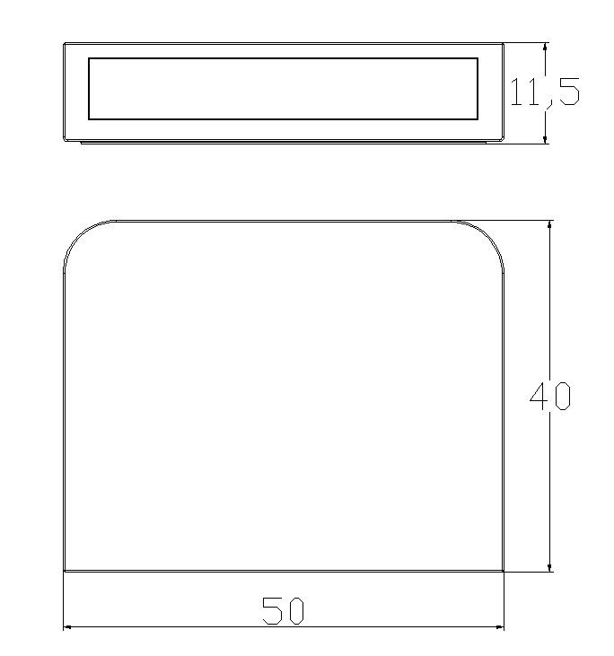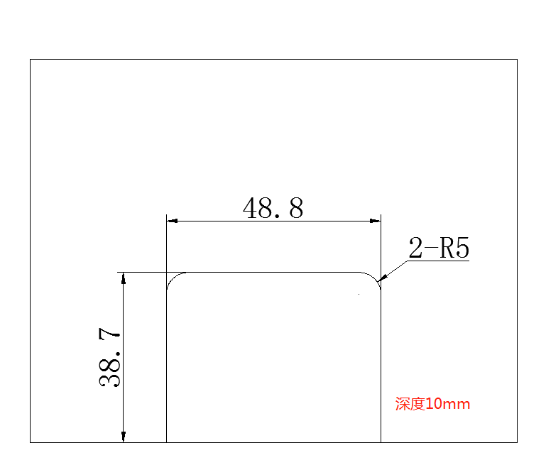
Product size diagram The screw installation of the visible lock does not need to open a slot, and the wood board needs to be processed with a slot when embedded as shown in the figure above Product size diagram The screw installation of the visible lock does not need to open a slot, and the wood board needs to be processed with a slot when embedded as shown in the figure above

4. Code matching, code clearing and learning operation of wireless switch
The wireless remote control should be coded with our control box in the following way to realize the matching use of the transmitter and receiver.
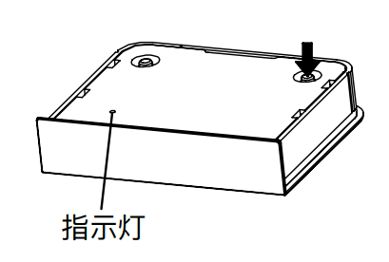
Code mode:
After connecting the lamp to the intelligent power supply or control box, power on the equipment. Within 30S after powering on the equipment, long press the code key of the remote control. When the lamp flashes three times, it indicates that the code is successful at this time, and the remote control can control this group of lamps.
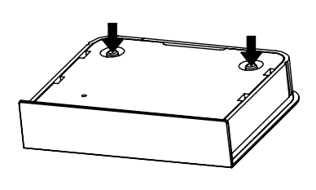
Clear code method:
Before the receiving end is powered on, press the code key and the code clearing key for about 5S at the same time. The lamp will flash three times, and the code clearing is successful at this time; the remote control can no longer control this receiving end.

Learning methods between remote controls:
