

**specification**

1G22

S1015D

Ultra-thin power wireless receiver controller

Date: November 28, 2022 Version：V1.0

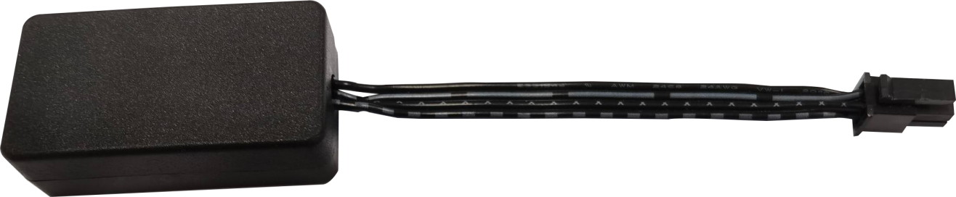

Business Telephone:(965)232-5320

Company:ARTCILUX LIGHTING INC

Address:1024 FAIRVIEW

technical specifications

* Working voltage: 12/24VDC

* Standby power consumption <0.1W

* Load power: 60W

* Brightness level: 1000

* Color temperature grade: 1000

* Wireless frequency: 2.4GHz

* Working temperature: -20°C~+50°C

* Installation method: open type

* External dimensions: 48.4mm*26.2mm*15.2mm

* Appearance color: black

product description

The S1015D wireless remote control utilizes the popular radio technology to achieve wireless control of the lighting fixtures. This application makes controlling LED lighting more convenient, flexible, and straightforward. When paired with our company's smart power supply and wireless switches, the LED lighting can be controlled wirelessly for functions such as adjusting brightness, color temperature, and switching.

product features

Low energy consumption, sensitive induction, low heat, stable and reliable

Application sites

Used for wardrobe, wine cabinet, kitchen interior and other local decorative lighting

Remote control box description (from left to right)

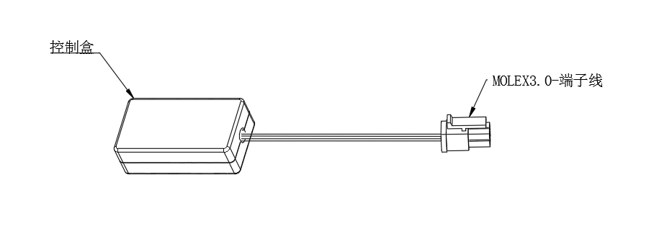

控制盒：Control box

MOLEX3.0-端子线：MOLEX3.0-terminal wire

1. **Product size diagram & wiring installation diagram**
2. **Product size diagram**

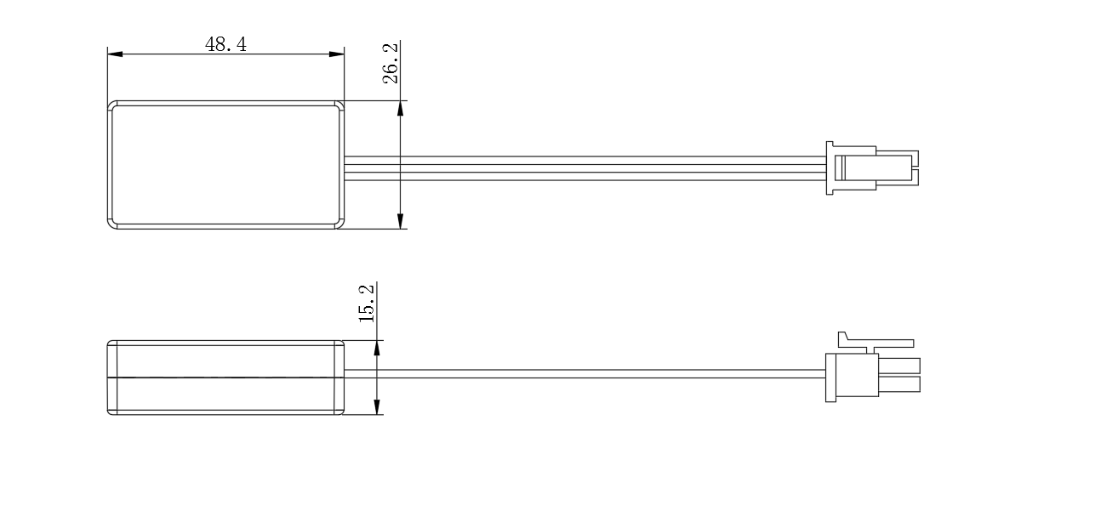

1. **Wiring installation diagram**

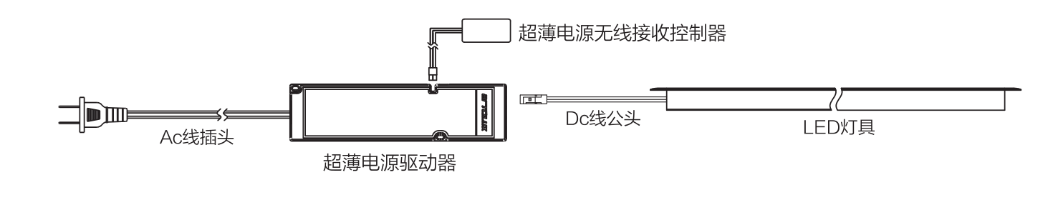

Ac线插头AC line plug

超薄电源无线接收控制器Ultra-thin power wireless receiving controller

超薄电源驱动器Ultra-thin power driver

Dc线公头Dc line male plug

LED灯具LED lamp