

**specification**

S1015AS

Single button touch dimming remote control

Date: November 21,2022 Version: V1.0

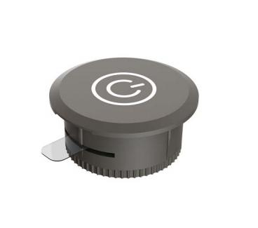

Business Telephone:(965)232-5320

Company:ARTCILUX LIGHTING INC

Address:1024 FAIRVIEW

product description

The S015AS single-key touch remote control uses a low-cost, high-integration 2.4GHz wireless transceiver chip, the LT8920. This chip integrates a transmitter, receiver, frequency synthesizer, and GFSK modem. The transmitter supports adjustable power, while the receiver employs a digital spread spectrum communication mechanism, ensuring excellent performance in complex environments and strong interference. The peripheral circuit is simple, requiring only an MCU and a few passive components. To extend battery life, the S015AS single-key touch remote control reduces power consumption at every stage, with a minimum operating voltage of 2.2V and a minimum current of 5uA.

product features

Low energy consumption, sensitive induction, stable and reliable

Application sites

Used for wardrobe, wine cabinet, kitchen interior and other local decorative lighting

matters need attention

1. If there is any quality or fault problem, please replace the whole set of switch device.

2. It cannot be wrapped in metal.

3. If the wireless switch does not work properly, please check whether the battery is used up and replace the battery.

4, do not put the battery products into the fire, so as not to produce danger.

5. It is strictly prohibited to put battery products into liquid, such as water.

6. Prevent violent vibration, impact or compression during transportation, and handle with care during handling.

7. Using it in your hand will affect the control distance of the remote control.

Maintenance measures

1. To extend the service life of the remote control, please insert the isolation sheet when it is not used for a long time.

2. Battery products should be stored in a cool, dry and ventilated environment to avoid contact with fire sources and heat sources. When storing lithium batteries for a long time, it is recommended to place them in an environment with room temperature of 10-25 degrees and no corrosive gas.

on-product information

|  |  |  |  |
| --- | --- | --- | --- |
| working voltage | 2.2-3.6V | modulation mode | GFSK |
| service frequency | 2.4GHz | power supply mode | Button battery (CR1630) |
| Remote control distance | <6M | emission current | 8mA |
| stand-by time | Two years | Hibernation current | 6uA |

Typical application diagram

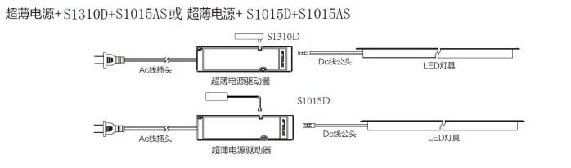

Ac线插头：AC line plug:超薄电源驱动器：ultra-thin power driver Dc线公头：Dc line male LED灯具：LED lamp

direction for use

1. Code: within 30 seconds after receiving power on, press the code key (S) of the remote control with a card needle. The light strip connected to the receiver will be turned on and off three times, indicating that the code is successful;

2. Clear code: within 30 seconds after receiving power on, long press the code key and clear code key (S+C), the receiver will clear the remote control code, and the remote control will no longer control the receiver

3. The remote controls learn from each other: Long press the code key (S) on remote control B for more than 5 seconds until the blue indicator light is always on. Press the code key on remote control A, and the B indicator light is turned off. At this time, the remote control B learns the address of remote control A

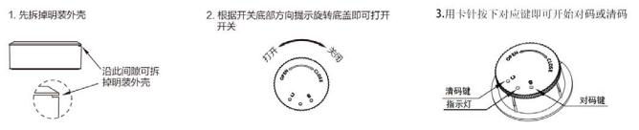

Installation method diagram

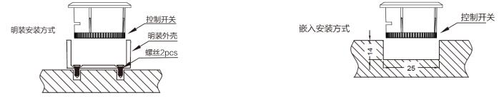

Product size diagram

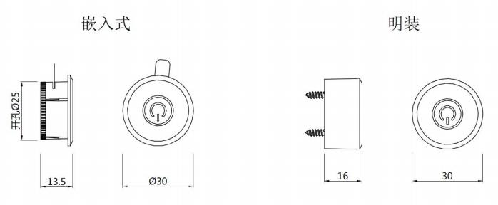

Product explosion diagram

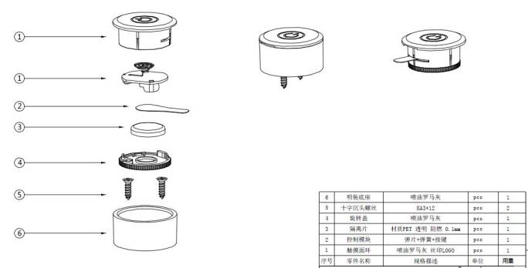

matters need attention ：

1. When installing PCBA, attention must be paid to the installation direction;

2. After the antenna is welded, adjust the antenna so that it is close to the shell.