

**specification**

Tian Tai A1620

A2D06 Mirror headlights

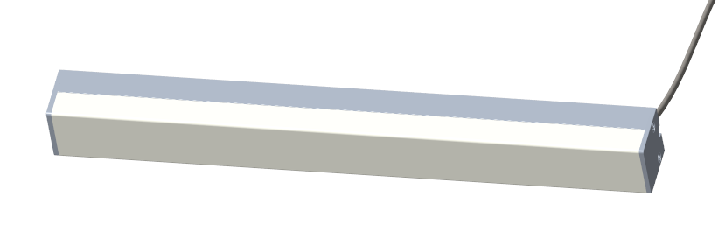

Product model: A2D06

Version: V1.0

Date: March 7, 2023

Company:ARTCILUX LIGHTING INC

Business Telephone:(965)232-5320

Address:1024 FAIRVIEW AVE

www.artcilux.us

**product description ：**

1. Simple and reliable installation of visible clips.

2. The milky white PC lampshade covers the light, and the light is soft without obvious glare.

3. Length is customizable

4. Suitable for bathroom cabinets, makeup mirrors and other furniture local lighting.

**Product Parameter**

|  |  |
| --- | --- |
| product name | Taitai 1620 headlight |
| product model | A2D06 |
| Shell material | aluminium +PC |
| specification and dimension | L is 16mm long x20mm wide x 20mm high |
| Angle of emission | $$300°$$ |
| color rendering index （Ra） | ≥90 |
| colour temperature | Warm white, true white, cold white |
| working voltage | DC12V |
| Product power | 10W/M |
| Light bulb specification | 2835 lamp beads / 120PCS/M |
| The input line is long | 1500mm |

**Size and packaging**

Size: L*16mm*20mm Packaging: white box + outer box Size: L*16mm*20mm Packaging: white box + outer box

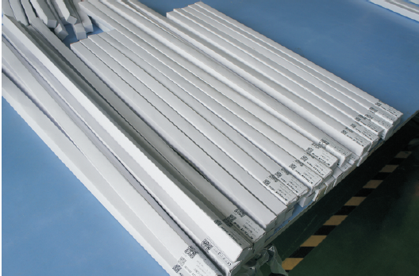

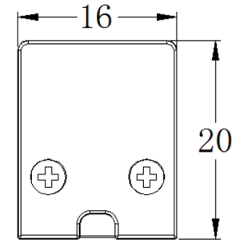

**Installation method: open installation**

(1). Attach the clip according to the required position

(2) Pass the input line through the wire hole and connect it

(3). Install the lamp on the clip.

**application scenarios**

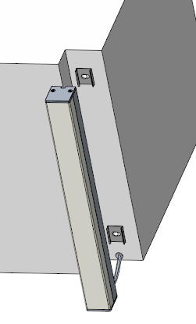

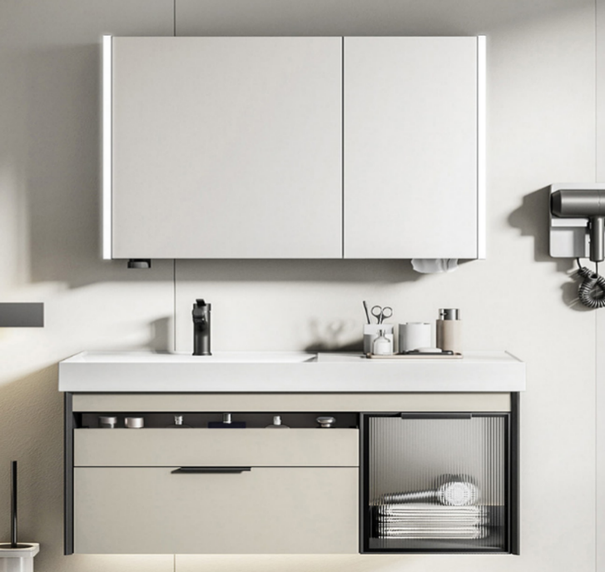

**Safety instructions**

 Only for indoor use 

 Regularly check that the wires, transformers and all other parts are not damaged  If any parts are damaged  The product should not be used 

 When installing and using the lamp, please strictly follow the requirements of this manual   Keep this manual for future use 

 The light source of this product is non-replaceable LED (LED) 

 Please do not install the lamp in the place where water drops leak.

**maintenance**

 The external soft wire of the lamp cannot be replaced; if the lamp wire is damaged, the lamp should be discarded and can not be used continuously. Different installation surface materials must use different hardware fittings .  Be sure to select the appropriate screws and bolts according to the specific fixed installation surface

** Please use a dry cloth to clean, do not use strong cleaning agent **