

**specification**

A260F.25 rear shelf lamp

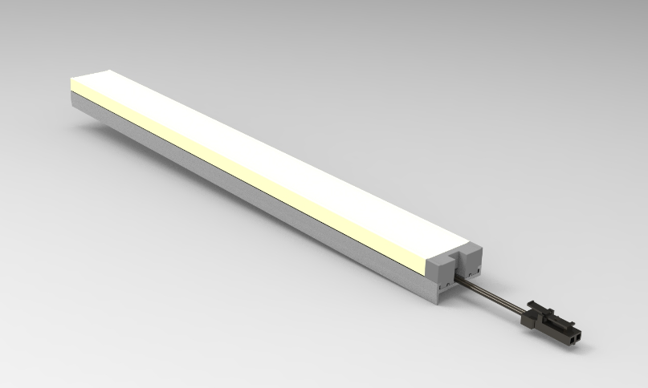

Product model: A260F.25

Version: V1.0

Date: August 25,2021

Company:ARTCILUX LIGHTING INC

Business Telephone:(965)232-5320

Address:1024 FAIRVIEW AVE

[www.artcilux.us](http://www.artcilux.us)

**1. Product Description:**

1. Rear shelf installation.

2. Dual-color PC mask guides light, emitting light from top to bottom, and the light is soft and glare-free.

3. Length is customizable

4. Suitable for cabinet, wardrobe, display cabinet and other furniture local lighting and atmosphere lighting.

5. Narrow light emission, placed behind the 25mm layer board, including glass or wood layer board.

**2. Product parameters**

|  |  |
| --- | --- |
| product name | Posterior layerboard lamp |
| product model | A260F.25 |
| Shell material | aluminium +PC |
| specification and dimension | 200-2850 (length) x26 (width) x15mm (height) |
| The size of the layer plate is reduced | 10.5mm |
| Angle of emission | $$120°$$ |
| color rendering index （Ra） | ≥90 |
| colour temperature | Warm white, true white, cold white |
| working voltage | DC12V / DC24V |
| Product power | 7.5W/M |
| Light bulb specifications | 2835 lamp beads / 120PCS/M |
| The input line is long | 1500mm |

**3. External dimensions and packaging**

Size: (200-2850)*26*15mm Packaging: white box + outer box Size: (200-2850)*26*15mm Packaging: white box + outer box

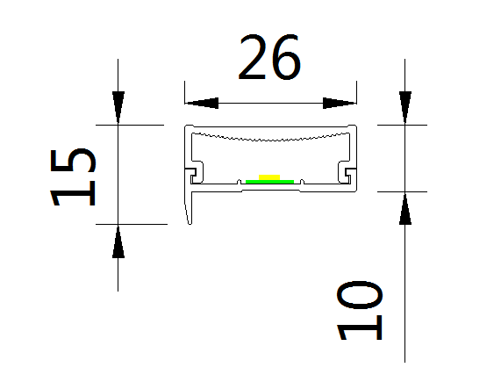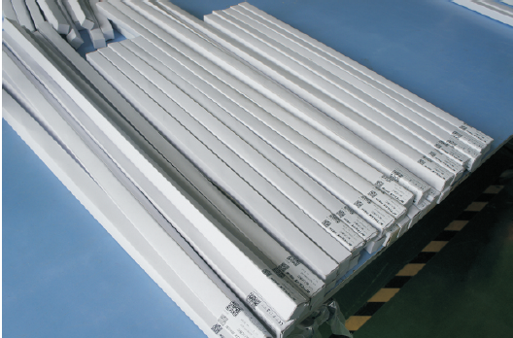

**4. Installation method**

(1).3M back adhesive installation, no need to open the light slot

(2) Pass the input line through and connect it

(3). Connect the lamp to the DC12V / DC24V power supply

**5. Application scenarios**

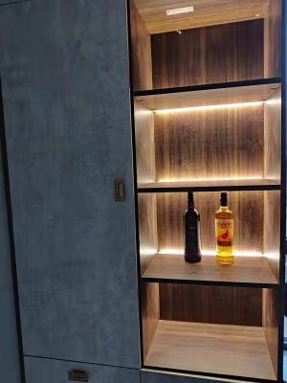

**6. Safety instructions**

* For indoor use only 

* Please regularly check whether the wires, transformers and all other parts are damaged. If any parts are damaged, the product should not be used 

When installing and using the lamp, please strictly comply with the requirements of this manual and keep this manual for future use 

* The light source of this product is a non-replaceable LED

* Please do not install the lamp in the place where water drops leak.

**maintenance**

* The external soft wire of this lamp cannot be replaced; if the lamp wire is damaged, the lamp should be discarded and cannot be used for different installation surface materials must use different installation hardware  Be sure to select the appropriate screws and bolts according to the specific fixed installation surface 

**\* Please use a dry cloth to clean, do not use strong cleaning**