

**specification**

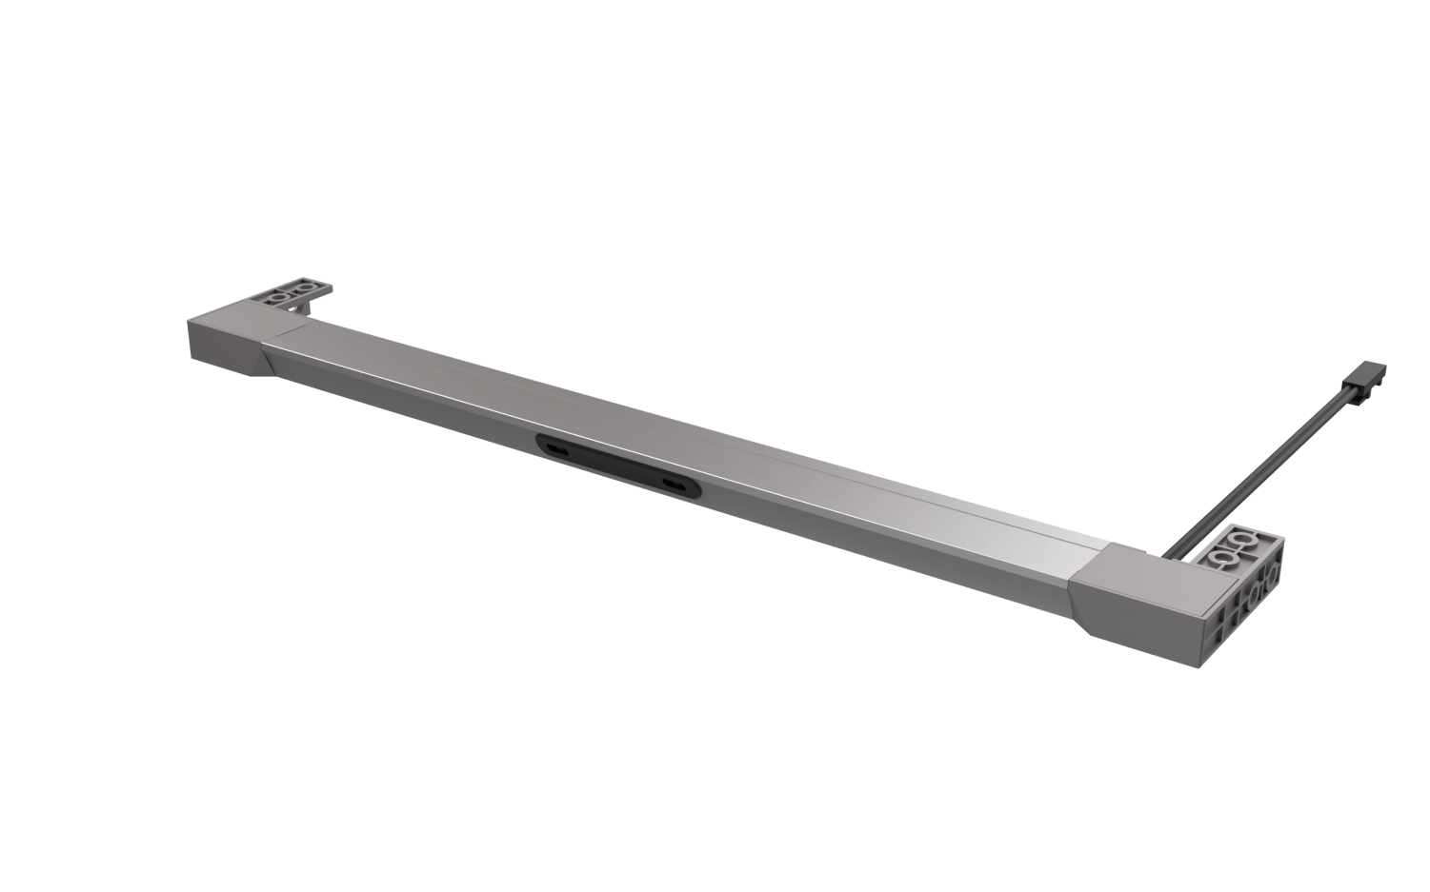

Sterilization lamp in cabinet

Product model: A2517

Version: V1.0

Date: September 26,2023

Company:ARTCILUX LIGHTING INC

Business Telephone:(965)232-5320

Address:1024 FAIRVIEW AVE

[www.artcilux.us](http://www.artcilux.us)

**1. Product Description:**

1. Small and ultra-thin, sterilization and lighting are used.
2. Simple installation, flexible application, cleverly installed in the drawer, in close cooperation with the drawer.
3. Humanized light source design, the maximum Angle of light illuminates the drawer, the light is soft and no glare.
4. The door touch control mode is that the drawer light will be turned on when the drawer is pulled, and the lighting lamp will be turned off when the drawer is closed, and sterilization will be automatically performed after 5 seconds.
5. Using UVC-LED sterilization principle, it is environmentally friendly and has a long life.

Warning: Purple light is invisible, direct exposure to the eyes and other exposed body surfaces may cause damage!

**2. Product parameters**

|  |  |
| --- | --- |
| product name | Sterilization lamp in cabinet |
| product model | A2517 |
| Exterior material | aluminium +PC |
| specification and dimension | 200~1500 (length) x37.5 (width) x9.6mm (height) |
| Angle of emission | $$120°$$ |
| color rendering index （Ra） | ≥90 |
| colour temperature | Warm white, true white, cold white |
| working voltage | DC12V |
| Product power | 5W/M (lighting), sterilization power 1W |
| Light bulb specifications | 2835 lamp beads / 168PCS/M, UV lamp beads: UVC-LED 3535UV wavelength 270-280nm |
| The input line is long | 1500mm |
| Bactericidal duration | After closing the door, it starts after 5 seconds of delay, sterilizes for 120 minutes at fixed time, and works in a cycle after 48 hours |

**3. External dimensions and packaging**

Size: 300-1500 (length) x37.5 (width) x9.6mm (height) Packaging: brown box + outer box Size: 300-1500 (length) x37.5 (width) x9.6mm (height) Packaging: brown box + outer box

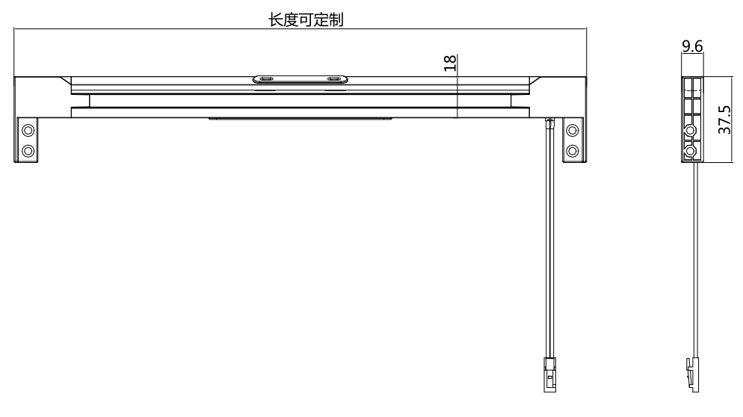

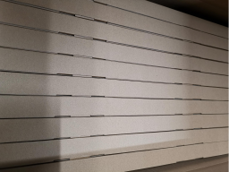

**4. Installation method**

4.1. The lamp is installed 10MM away from the door panel, and the lamp wire is fixed with a clamp.

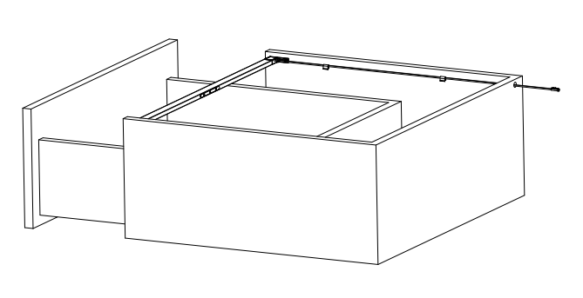

4.2. The end covers on both sides can be fixed by screws, which can be installed on top or side.

After the installation is completed, it will be lit up when powered on (note that sterilization will be carried out automatically 5 seconds after closing the drawer).

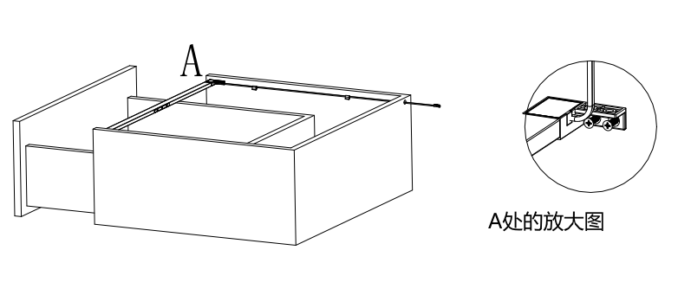

**5. Application scenarios**

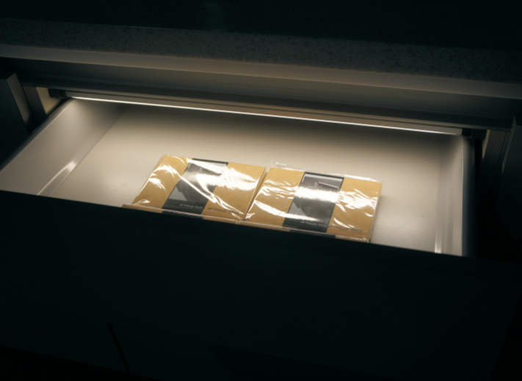

**6. Safety instructions**

* For indoor use only 

* Please regularly check whether the wires, transformers and all other parts are damaged. If any parts are damaged, the product should not be used 

When installing and using the lamp, please strictly comply with the requirements of this manual and keep this manual for future use 

* The light source of this product is a non-replaceable LED

* Please do not install the lamp in the place where water drops leak.

**maintenance**

**The external soft wire of this lamp cannot be replaced; if the lamp wire is damaged, the lamp should be discarded and cannot be used for different installation surface materials must use different installation hardware  Be sure to select the appropriate screws and bolts according to the specific fixed installation surface, please clean with a dry cloth, do not use strong cleaning.**