

**specification**

Phoenix 0508

A220T ultra-thin embedded strip lamp

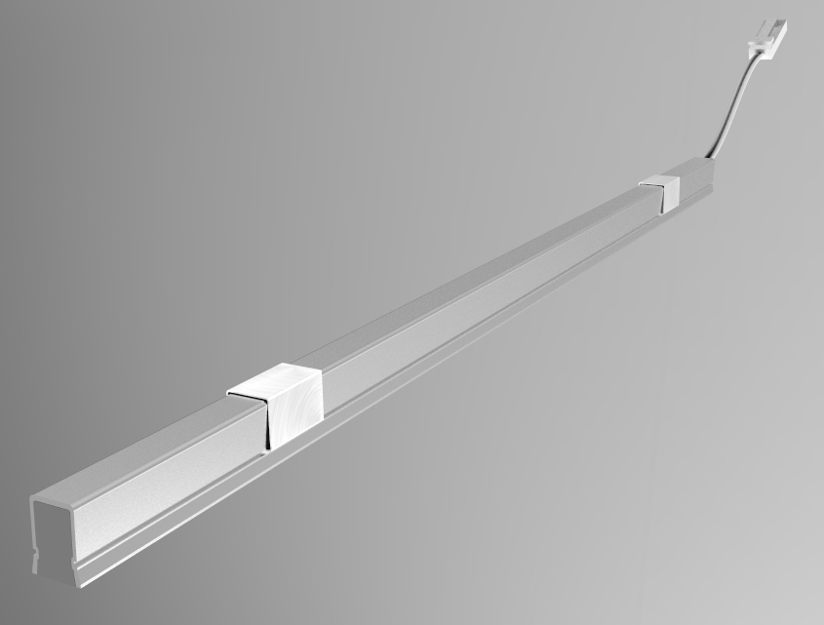

Product model: A220T

Version: V1.0

Date: December 12,2020

Company:ARTCILUX LIGHTING INC

Business Telephone:(965)232-5320

Address:1024 FAIRVIEW AVE

www.artcilux.us

**product description ：**

1. Ultra-thin product design, 12V safe low voltage drive

2. Silicone gel light guide, soft light without glare.

3. The spring clip is installed in a simple and reliable way

4. Suitable for cabinet, wardrobe, display cabinet and other furniture local lighting and atmosphere lighting.

**Product Parameter**

|  |  |
| --- | --- |
| product name | Phoenix 0508 ultra-thin embedded lamp |
| product model | A220T |
| Exterior material | Aluminum + silica gel |
| specification and dimension | 200-2000 (length) x5 (width) x7mm (height) |
| color rendering index （Ra） | >90 |
| colour temperature | 3000K，4000K，6500K |
| working voltage | DC12V |
| Product power | 6W/M |
| Light bulb specifications | 2010 LED beads / 192PCS/M |
| The input line is long | 1500mm |

**Size and packaging**

Size: (200-1500)*5*7.25mm Packaging: white box + outer box Size: (200-1500)*5*7.25mm Packaging: white box + outer box

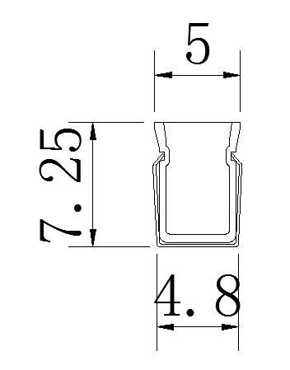 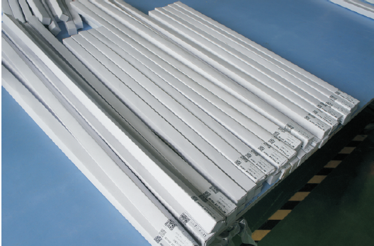

**Installation method: embedded installation**

(1). Slot according to the required position (slot width: 5mm; depth: 8mm; length = product length)

(2) Install the lamp in the groove.

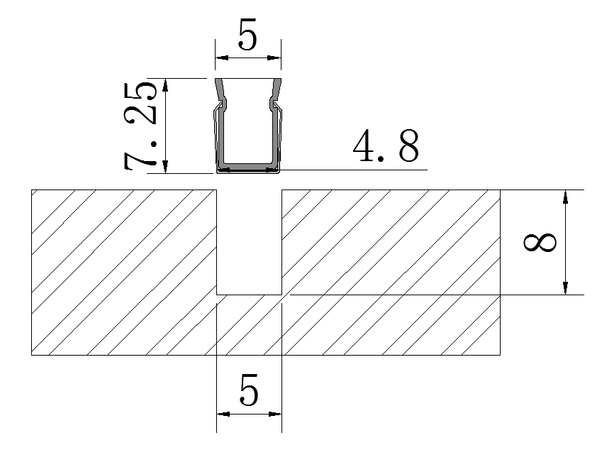

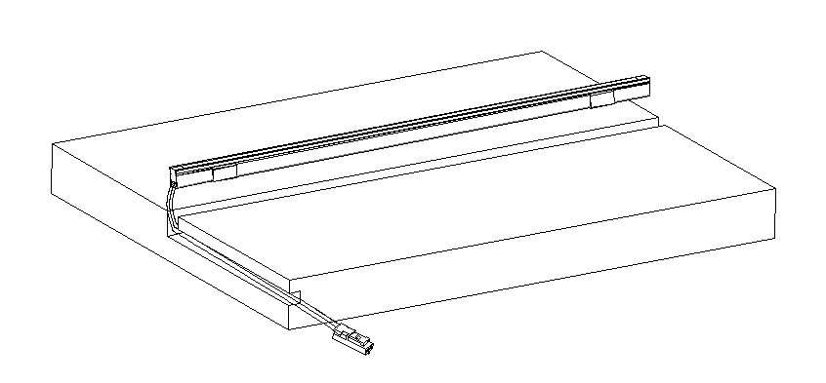

**application scenarios**

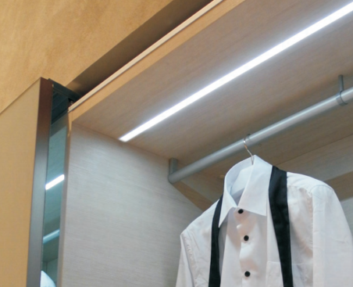

**Safety instructions**

 Only for indoor use 

 Regularly check that the wires, transformers and all other parts are not damaged  If any parts are damaged  The product should not be used 

 When installing and using the lamp, please strictly follow the requirements of this manual   Keep this manual for future use 

 The light source of this product is a non-replaceable LED (☹)

 Please do not install the lamp in the place where water drops leak.

**maintenance**

 The external soft wire of the lamp cannot be replaced; if the lamp wire is damaged, the lamp should be discarded and can not be used continuously. Different installation surface materials must use different hardware fittings .  Be sure to select the appropriate screws and bolts according to the specific fixed installation surface

** Please use a dry cloth to clean, do not use strong detergent **