

specification
A112D square cabinet light
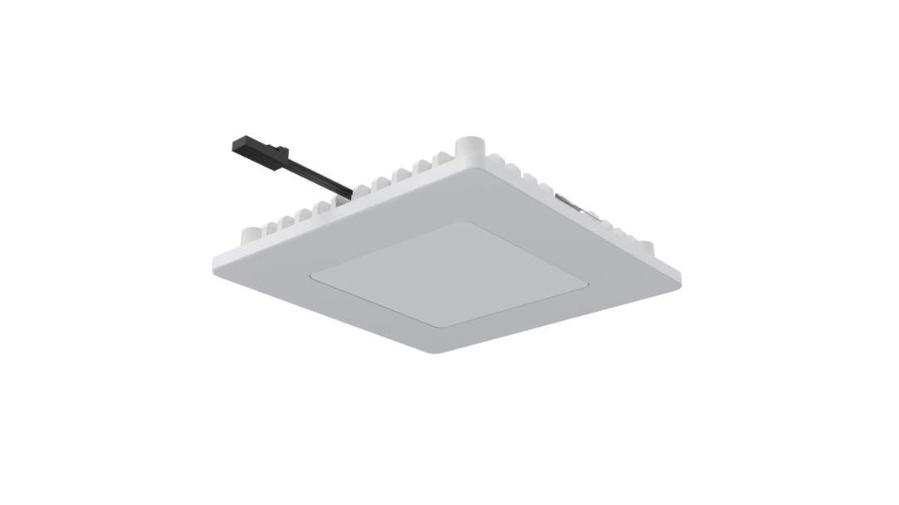
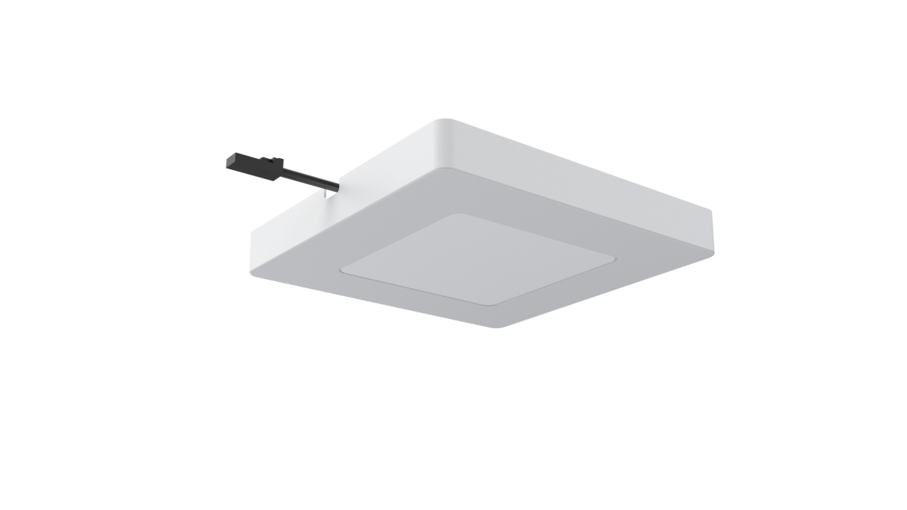

Model: A112D
Version: V1.0
Date: 2023.05.1

Company:ARTCILUX LIGHTING INC
Business Telephone:(965)232-5320
Address:1024 FAIRVIEW AVE
www.artcilux.us

product description ：
- Cabinet lamp, ultra-thin product design, 12V safe low voltage drive
- The light is uniform
- The radiator is made of aviation aluminum and has excellent heat dissipation
- The lamp supports two installation methods: embedded installation and open installation
Product Parameter ：
product model | A112D
working voltage | DC12V
Product power | 2.5W
specification and dimension | 76*76*10mm
color rendering index | CRI>90
colour temperature | 3000K/4000K/6000K
Exterior material | PC + aluminum radiator
Light bulb specification | 3528 lamp beads
The input line is long | 1.5M

technical parameter ：
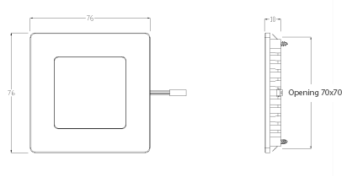

Packaging information: 95*95*15mm white box

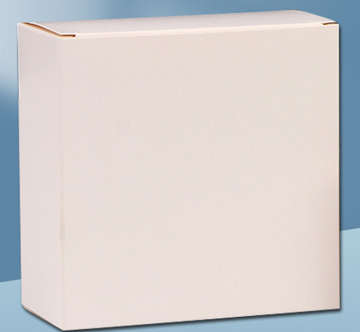

application scenarios ：
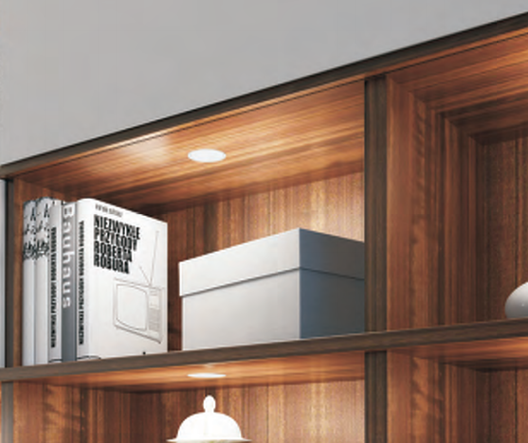

Safety instructions:
For indoor use only 
Please regularly check for damage to wires, transformers and all other components 
If any part is damaged  the product should not be used 
When installing and using the lamp, please strictly comply with the requirements of this manual  
Keep this statement for future use 
The light source of this product is a non-replaceable light-emitting diode
Do not install the lamp where water droplets leak.

maintenance
The external soft wire of this lamp cannot be replaced; if the lamp wire is damaged, the lamp should be discarded and cannot be used for different installation surface materials must use different installation hardware  Be sure to select the appropriate screws and bolts according to the specific fixed installation surface 
Please use a dry cloth to clean, do not use strong detergent

