

**specification**

**A112C round cabinet light**

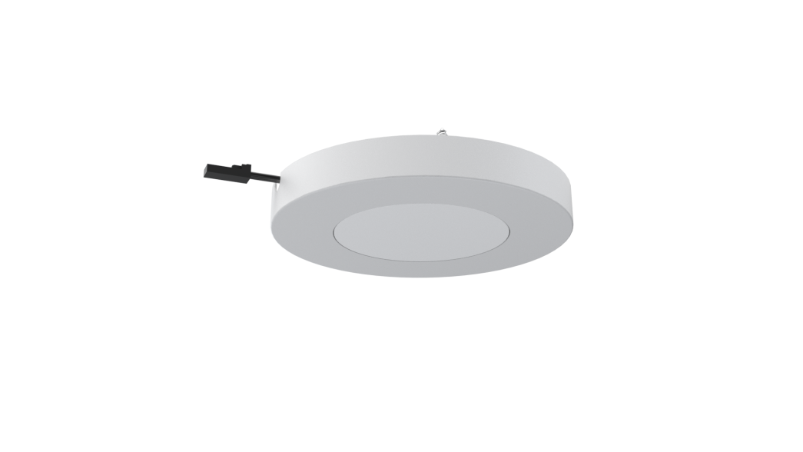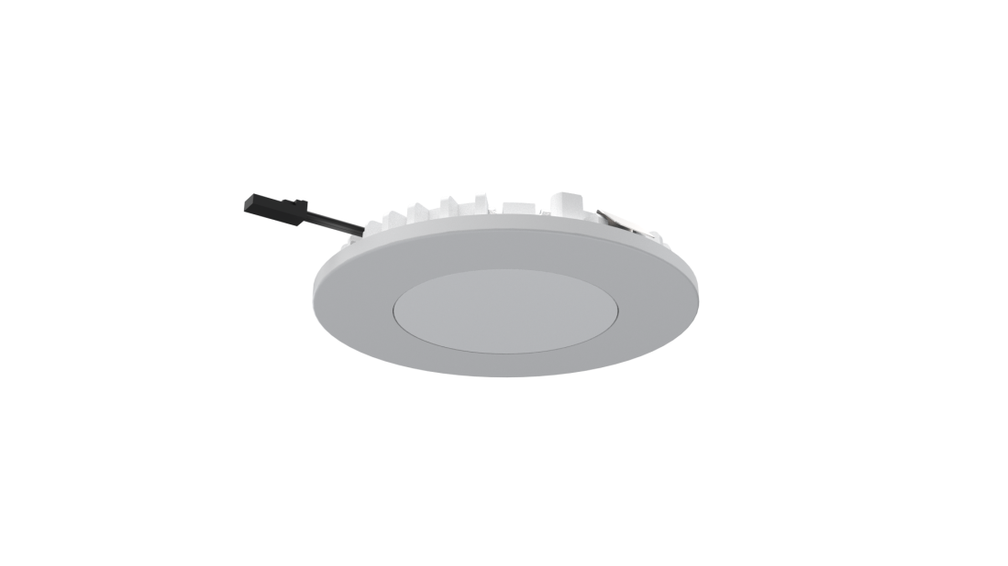

**Model: A112D**

**Version: V1.0**

**Date: 2023.05.1**

Company:ARTCILUX LIGHTING INC

Business Telephone:(965)232-5320

Address:1024 FAIRVIEW AVE

www.artcilux.us

**product description ：**

1. Cabinet lamp, ultra-thin product design, 12V safe low voltage drive
2. The light is uniform on the surface
3. The radiator is made of aviation aluminum and has excellent heat dissipation
4. The lamp supports two installation methods: embedded installation and open installation

**Product Parameter ：**

|  |  |
| --- | --- |
| product model | A112C |
| working voltage | DC12V |
| Product power | 2.5W |
| specification and dimension | φ76*10mm |
| color rendering index | CRI>90 |
| colour temperature | 3000K/4000K/6000K |
| Exterior material | PC + aluminum radiator |
| Light bulb specification | 3528 lamp beads |
| The input line is long | 1.5M |

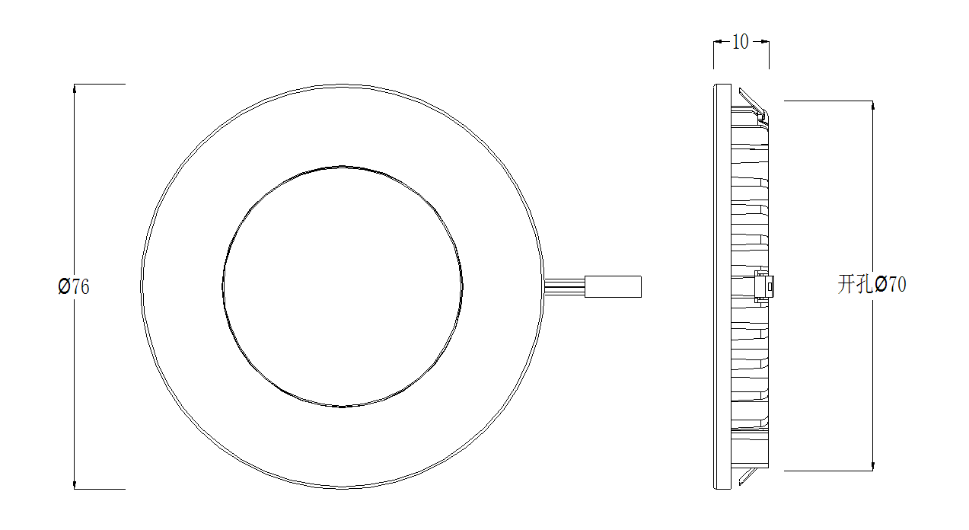 **technical parameter ：**

**Packaging information: 95*95*15mm white box**

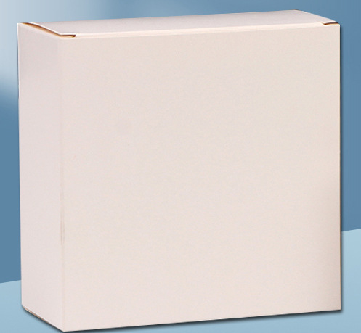

**application scenarios ：**

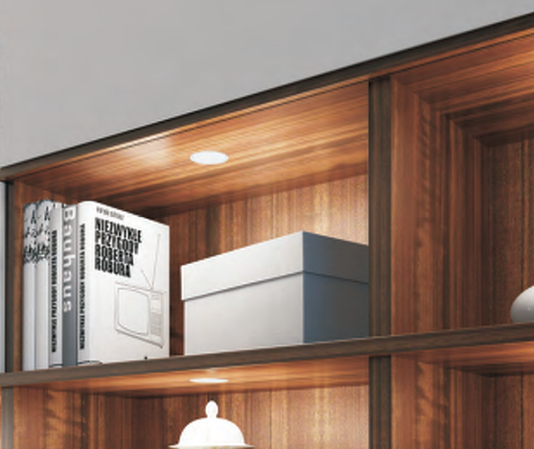

**Safety instructions:**

For indoor use only 

Please regularly check for damage to wires, transformers and all other components 

If any part is damaged  the product should not be used 

When installing and using the lamp, please strictly comply with the requirements of this manual  

Keep this statement for future use 

The light source of this product is a non-replaceable light-emitting diode

Do not install the lamp where water droplets leak.

**maintenance**

The external soft wire of this lamp cannot be replaced; if the lamp wire is damaged, the lamp should be discarded and cannot be used for different installation surface materials must use different installation hardware  Be sure to select the appropriate screws and bolts according to the specific fixed installation surface 

Please use a dry cloth to clean, do not use strong detergent