

**specification**

**A1117 embedded rotating focus spotlight**

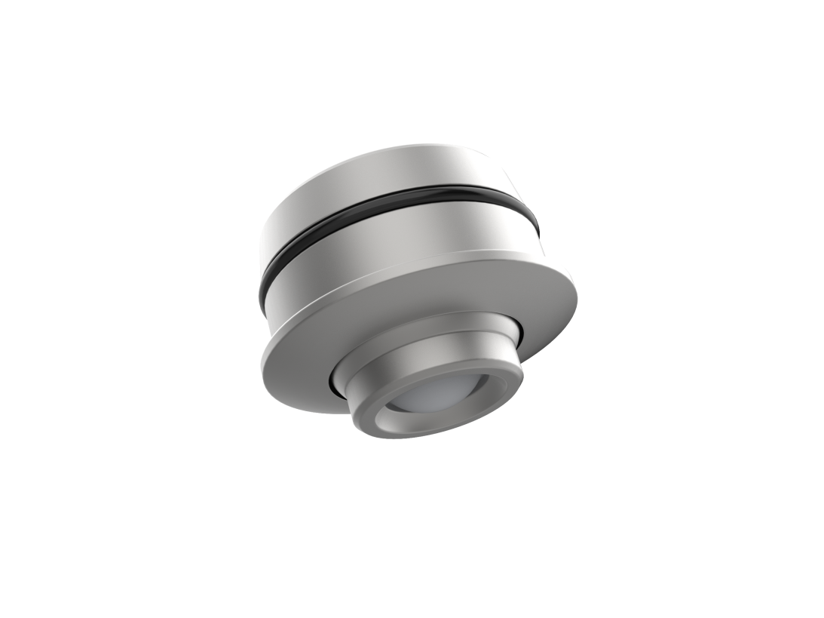

**Model: A1117**

**Version: V1.0**

**Date: 2024.06.7**

Business Telephone:(965)232-5320

Company:ARTCILUX LIGHTING INC

Address:1024 FAIRVIEW

**product description ：**

1. The product has a novel appearance and is easy to install
2. The radiator is made of aviation aluminum and has excellent heat dissipation
3. The lamp is supported for embedded installation

**Product Parameter ：**

|  |  |
| --- | --- |
| product model | A1117 |
| working voltage | DC12V |
| Product power | 1W±0.2 |
| specification and dimension | Φ28*18.7mm |
| Opening size | Φ25*12mm |
| colour temperature | 3000K / 4000K / 6000K |
| Shell material | Aluminum radiator (oxidized Milky Way gray) |
| Lighting bead parameters | 3535 lamp beads CRI>90 |
| Rotation Angle / Beam Angle | The rotation Angle can be adjusted from 0 to 30 degrees, and the beam Angle can be adjusted from 15 to 60 degrees |
| wire length | 1.5M |

**technical parameter ：**

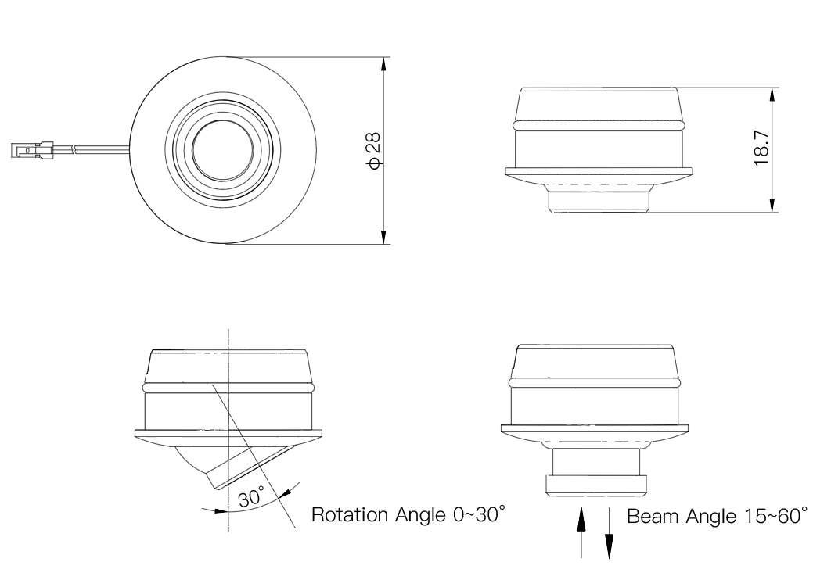

**application scenarios ：**

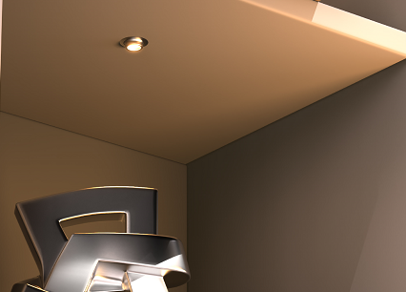

**Safety instructions:**

For indoor use only 

Please regularly check for damage to wires, transformers and all other components 

If any part is damaged  the product should not be used 

When installing and using the lamp, please strictly comply with the requirements of this manual  

Keep this statement for future use 

The light source of this product is a non-replaceable light-emitting diode

Do not install the lamp where water droplets leak.

**maintenance**

The external soft wire of this lamp cannot be replaced; if the lamp wire is damaged, the lamp should be discarded and cannot be used continuously. The installation hardware required by different installation surface materials must be different  Be sure to select the applicable screws and bolts according to the specific fixed installation surface 

Please use a dry cloth to clean, do not use strong detergent