

specification
A2Q0L embedded strip light
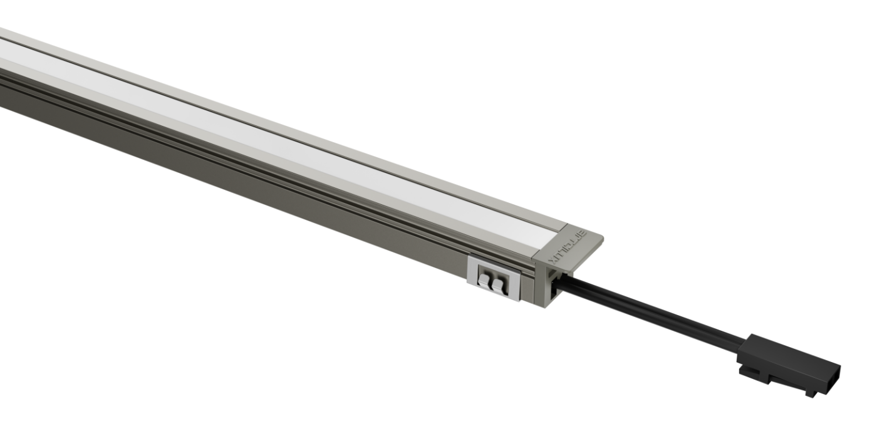
(Forward light emission / oblique light emission) are shared

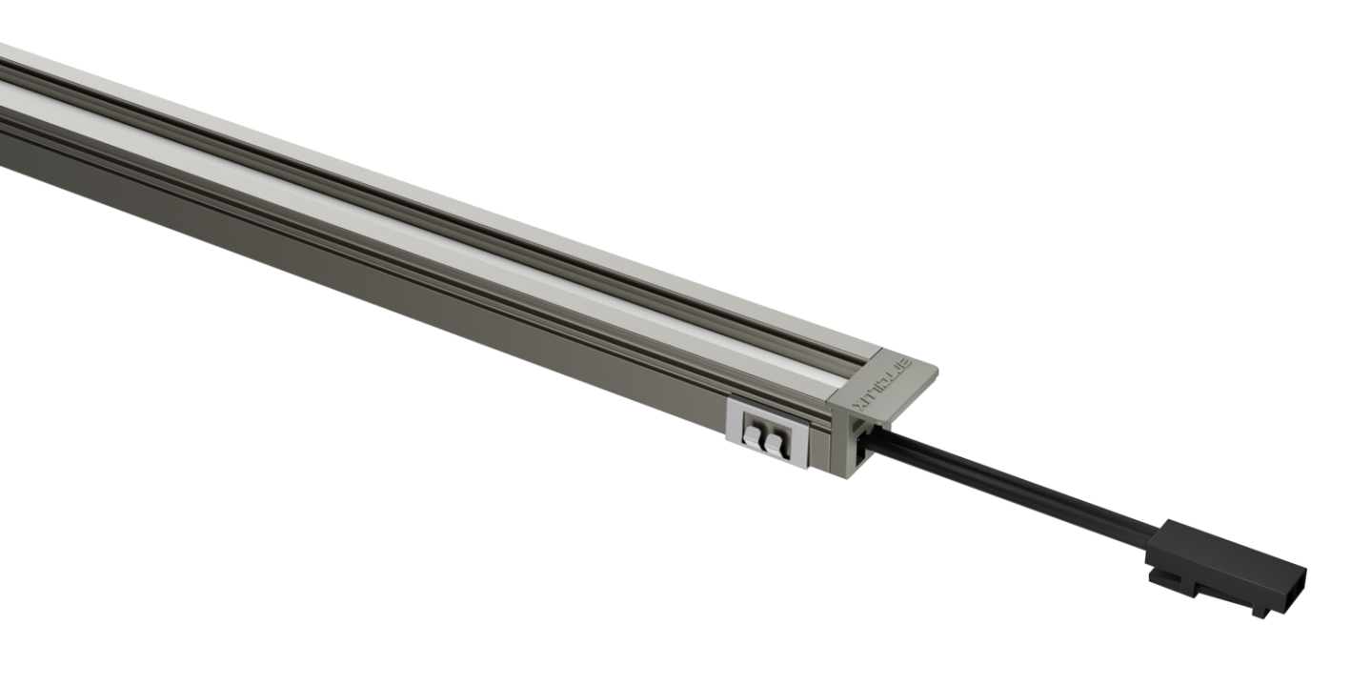

Model：A2Q0L
Version：V1.0
Date：2023.05.26
Business Telephone:(965)232-5320
Company:ARTCILUX LIGHTING INC
Address:1024 FAIRVIEW

product description ：
- Slot 10mm by 10mm
- 12V safe low voltage drive, no positive or negative, plug and play
- The radiator is made of aviation aluminum and has excellent heat dissipation
- The lamp supports two types of strip lights: positive light and oblique light
- The power terminals are inserted on both sides
Product Parameter ：
product model | A2Q0L
Product power | 7.5W
Slot size | 10*10mm
specification and dimension | 12*10*3000mm
color rendering index | CRI>90
colour temperature | 3000K/4000K/6000K
Exterior material | PC + aluminum radiator
Light bulb specifications | 2219 lamp beads
The input line is long | 1.5M
working voltage | DC12V

technical parameter ：

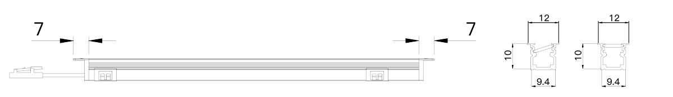

Packaging information: White box

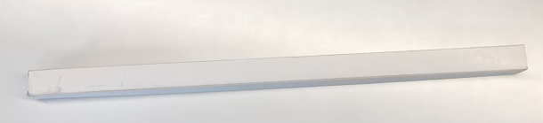

application scenarios ：

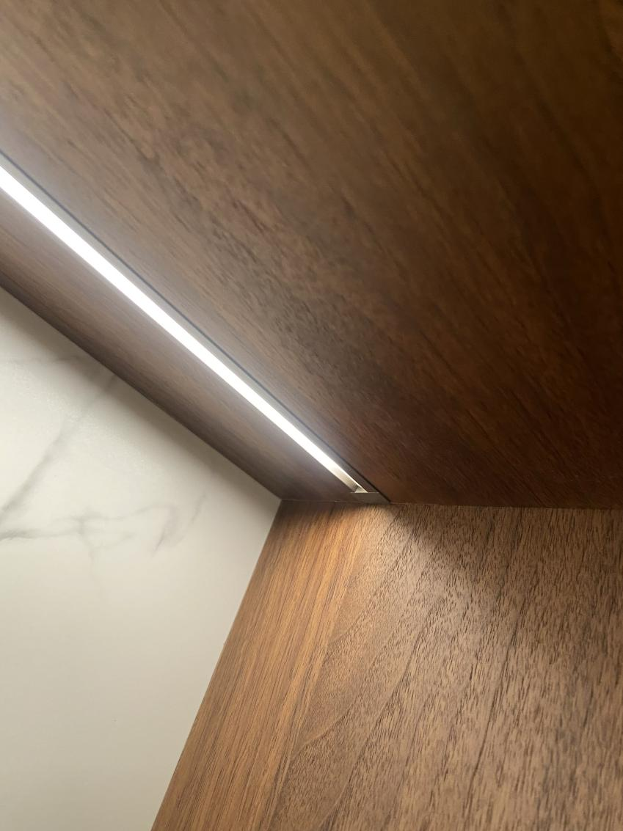

Safety instructions:
For indoor use only 
Please regularly check for damage to wires, transformers and all other components 
If any part is damaged  the product should not be used 
When installing and using the lamp, please strictly comply with the requirements of this manual  
Keep this statement for future use 
The light source of this product is a non-replaceable light-emitting diode
Do not install the lamp where water droplets leak.

maintenance
The external soft wire of this lamp cannot be replaced; if the lamp wire is damaged, the lamp should be discarded and cannot be used for different installation surface materials must use different installation hardware  Be sure to select the appropriate screws and bolts according to the specific fixed installation surface 
Please use a dry cloth to clean, do not use strong detergent

