

Specifications
4G12.2
4G12.2
S1312SE.2IR Wireless Double Door Touch Sensor Remote Control Switch
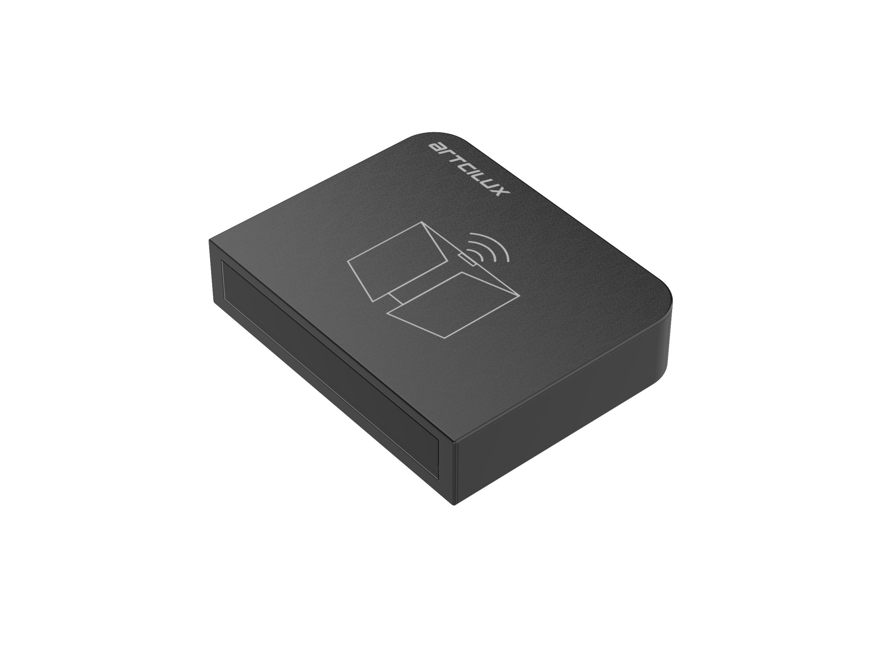
Product Model: S1312SE
Version: V1.0
Date: 2022.12.27

Business Telephone:(965)232-5320
Company:ARTCILUX LIGHTING INC
Address:1024 FAIRVIEW

E-mail：artcilux@ artcilux.com

www.artcilux.us
- Product Overview
S1312SE.2IR Wireless Door Touch Sensor Remote Control Switch adopts 2.4GHz wireless radio frequency control method, which can be matched with our control box to realize wireless control function of lamps. It adopts replaceable CR2450 button battery, and can control the wireless control box with a distance of 10M in open places. The appearance is neat and elegant, light luxury and beautiful; it adopts advanced low-power chip and has a long standby time; this product has the advantages of environmental protection and energy saving, simple use, and no need for wiring. It is an excellent solution for furniture LED lighting control.

- Technical parameters of wireless remote control

Ambient temperature | -20℃~50℃ |  | Working voltage | 3.0~3.3V
Battery model | CR2450 |  | Modulation mode | GFSK
Standby power consumption | <0.2mW |  | Working power consumption | <60mW
Wireless transmission frequency | 2.4GHz |  | Remote touch distance | 10M
门触感应距离 | 1-3cm |  | Product size | 50*40*11.5*mm

3. Product size drawing and wood processing drawing
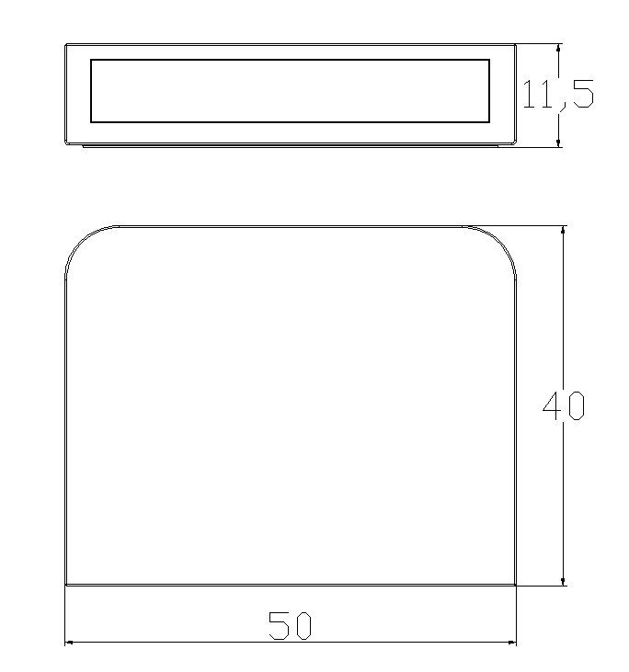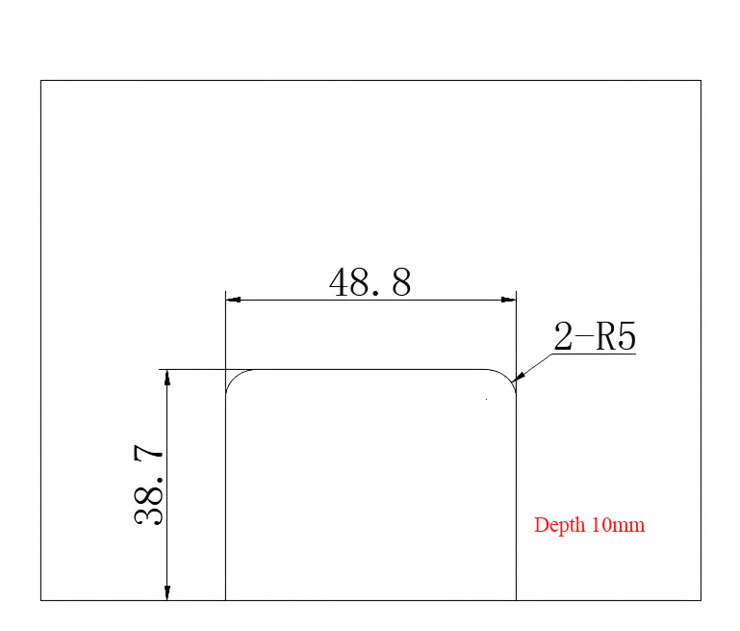
Product size drawing No need to cut grooves for surface-mounted screw installation, and the wood needs to be processed into grooves as shown above when embedded

- Code matching, code clearing and learning operation of wireless switch
The wireless remote control needs to be matched with our control box in the following way to realize the matching use of the transmitter and the receiver.
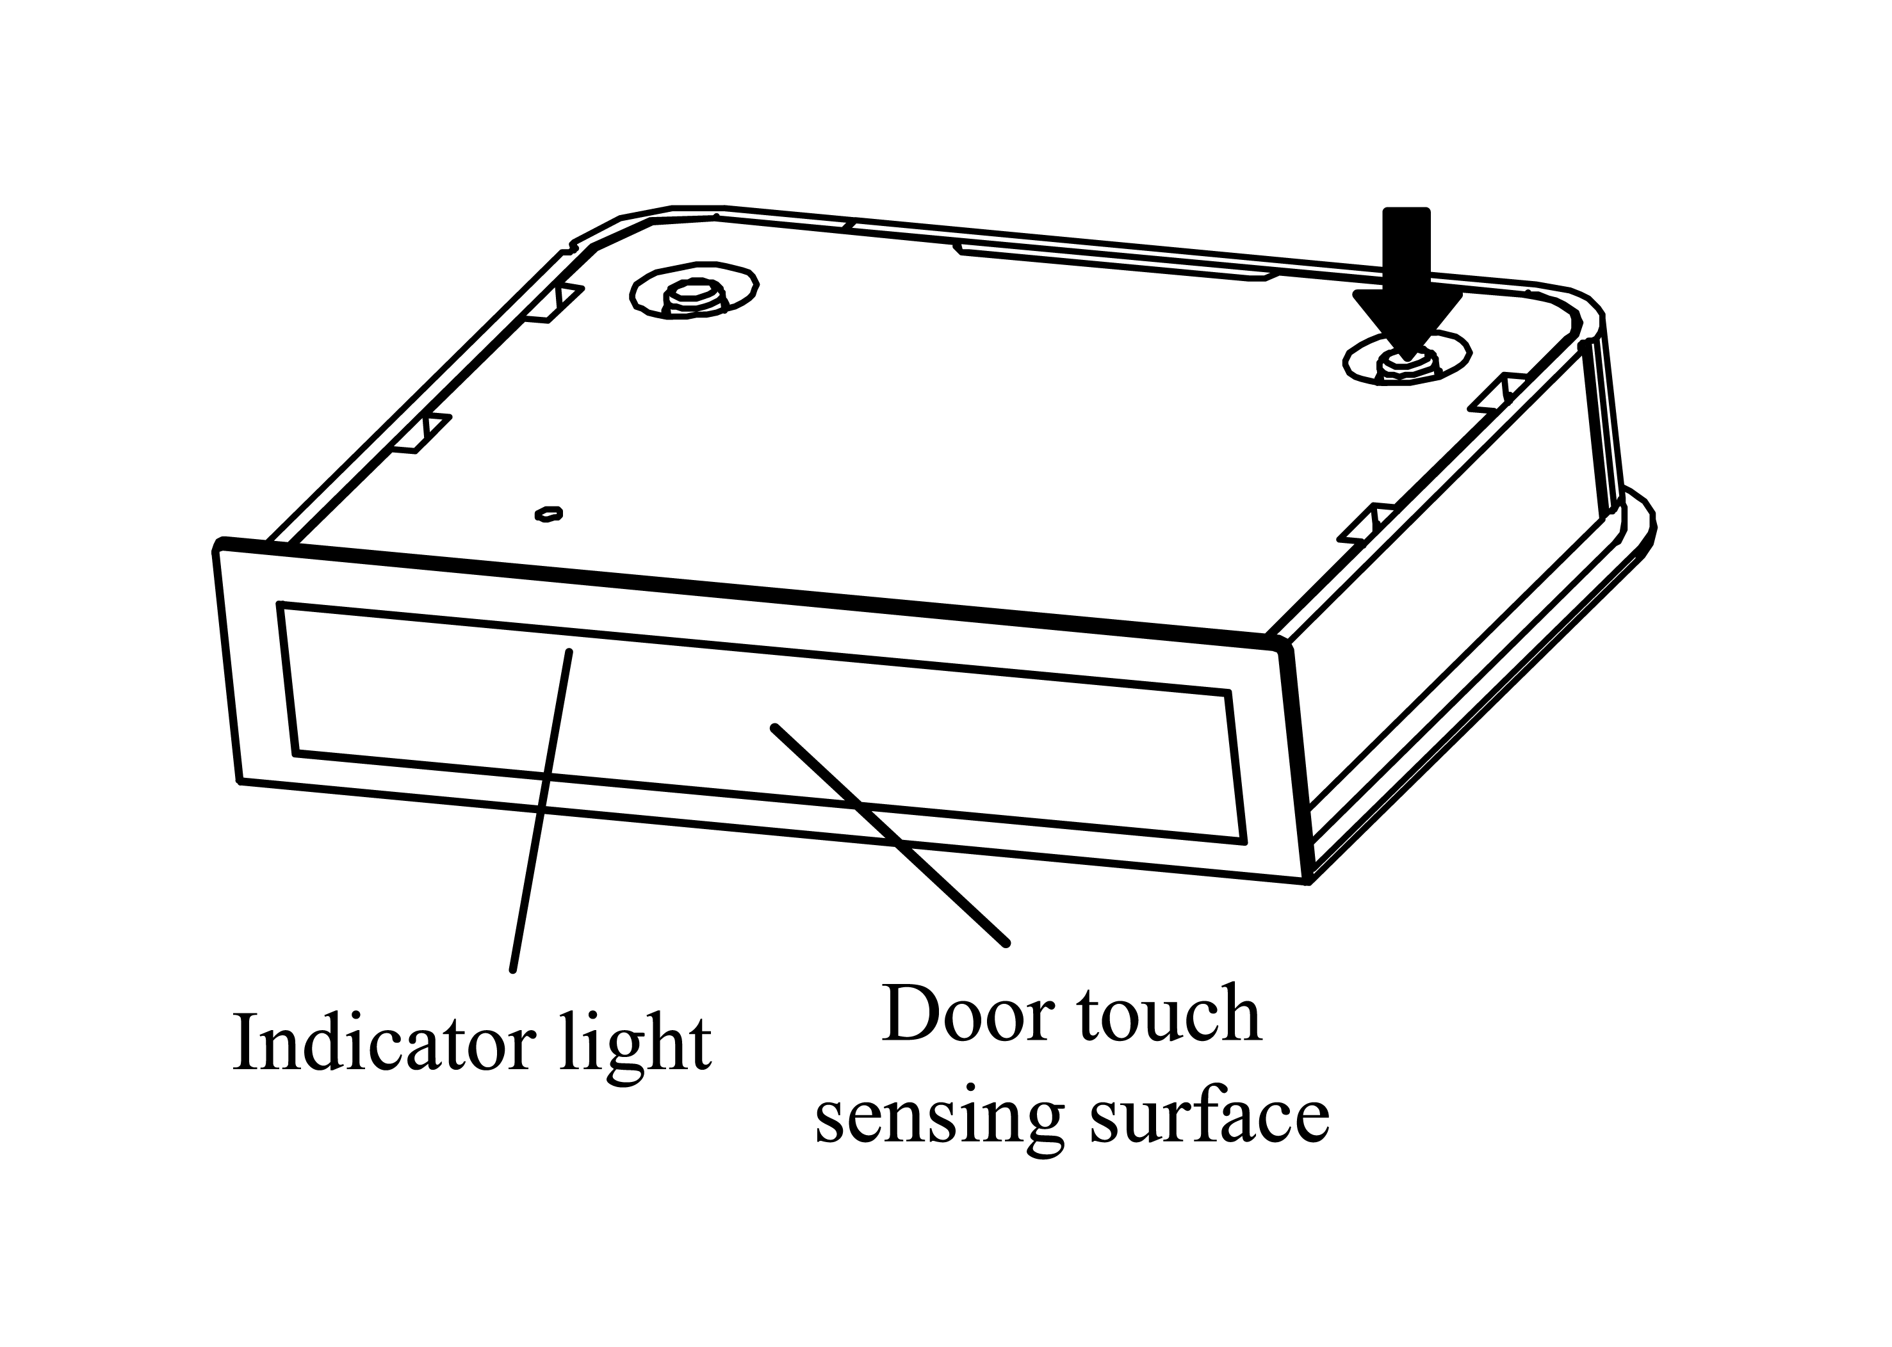
Code matching method：
Connect the lamp to the smart power supply or control box and power on the device. Within 30 seconds after the device is powered on, long press the pairing button of the remote control. When the lamp flashes 3 times, it means that the pairing is successful and the remote control can control this group of lamps.
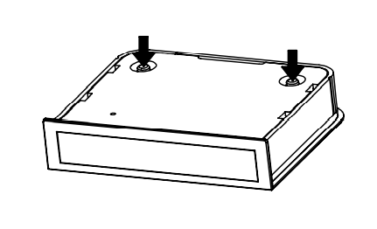
Clearing method：
5S before the receiving end is powered on, press the pairing button and the clearing button at the same time for about 5S. The lamp flashes 3 times. At this time, the clearing is successful; the remote control can no longer control this receiving end.

Learning method between remote controls：
